BASE FILE POSTGRESQL

USER GUIDE

Table des matières

Introduction 4

**PostgreSQL As A Service :** 4

Prerequisites 4

Process Workflow 4

Step 1: 4

Step 2: 4

MODIFICATION HISTORY & REVIEWS

|  |  |  |  |
| --- | --- | --- | --- |
| Date | Version | Author | Description |
| 09/03/2017 | V0.1 | EL AABOUDI Karim | Initial version |
| 12/02/2018 | V0.2 | EL AABOUDI Karim | Add ITIM specific step |
| 06/06/2018 | V1 | EL AABOUDI Karim | Use JUMP catalog |
| 04/09/2018 | V1.1 | EL AABOUDI Karim | Re-Add ITIM verification |
| 23/01/2019 | V2 | EL AABOUDI Karim | Add PGaAS link |
| 02/04/2019 | V2.1 | EL AABOUDI Karim | Add Control-M as a prerequiste |

# Introduction

This document describes how to ask for a new postgresql database.

# **PostgreSQL As A Service :**

**Please consider using the PostgreSQL As a Service (** [**http://go/doitnow**](http://go/doitnow) **) first before asking the dba team to create a database as described below.**

# Prerequisites

Before asking for a new postgresql database, you will need:

1. A Provisioning Number for your application: PR is necessary to allocate storage for your database files systems (PR is not necessary if the size of database is below 2To).
2. A trigram project: The trigram project must be in the KAT repository (<http://go/kat>)
3. A server name: The server must be in MARLEY repository (<http://go/marley>)
4. Control-M Agent: Please install control-m agent before on the server before asking for a database

# Process Workflow

## Step 1:

The ME must fill the form:

<https://mind.fr.world.socgen/ope/retdatabase/Documents_Public_Content/Dossier_de_base_Postgres_TRIG_ENV.xlsx>

**For ITIM only :**

The xlsx file contentmust be verified and approvedby a member of the DBAE team in charge of the project, through a JIRA demand (<https://jira.socgen/projects/DBAE>).

## Step 2:

The ME must order a change from the catalog on ITSM (<https://corporate.jump.socgen/sm/index.do>) and attach the form above.

In change Management > Changes > Order from Catalog, search for “PostgreSQL” (respect the case) and order the service “[POSTGRESQL] Create a database cluster”

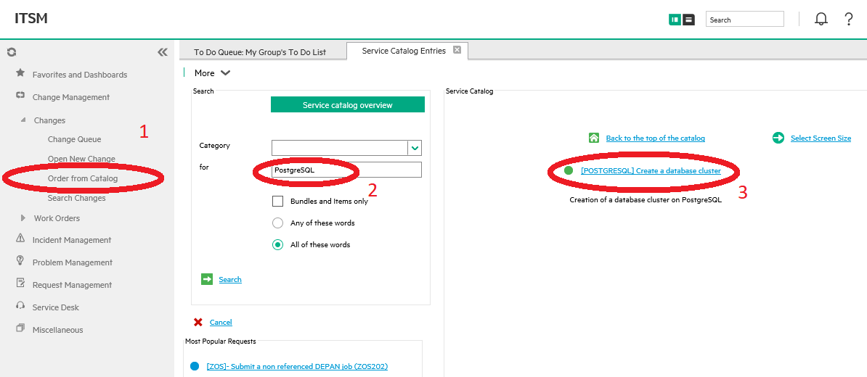

Then click on the “next” button, to move to the submit screen. Fill in the required fields, and attach the form you completed in the step 1.

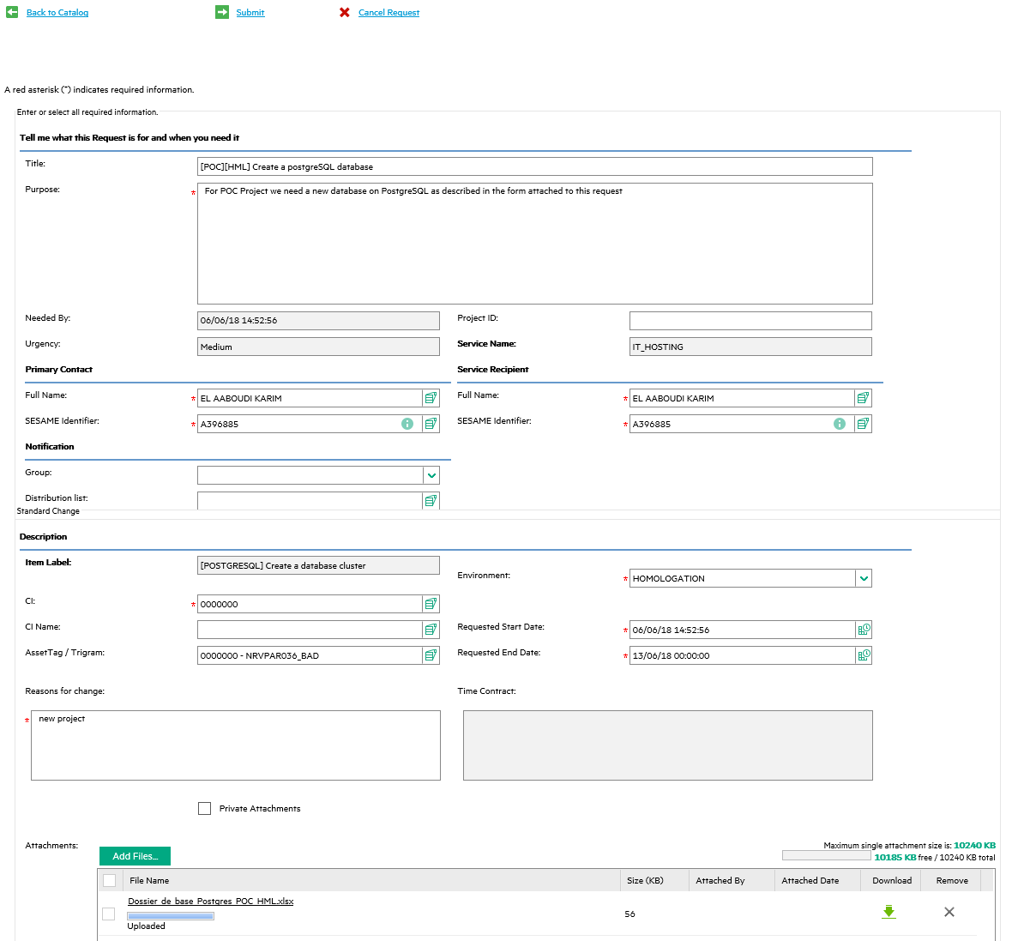

Finally, submit the request and keep the request number for tracking purpose.